

**VS Code CheatSheet**

**Intellisense**

IntelliSense is a code-completion aid that includes a number of features: List Members, Parameter Info, Quick Info, and Complete Word.

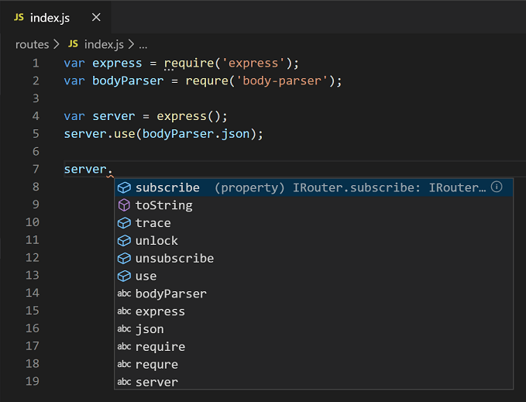

**Emmet**

Emmet uses different abbreviations and short expressions depending on what's passed, and then dynamically converts the abbreviations into the full code. Emmet is mostly used for HTML, XML, and CSS, but it can also be used with programming languages.

**Emmet documentation:** <https://docs.emmet.io/>

**Eg:** Typing ! in a .html file uses IntelliSense to suggest the Emmet Abbreviation which when clicked gives the following piece of code.





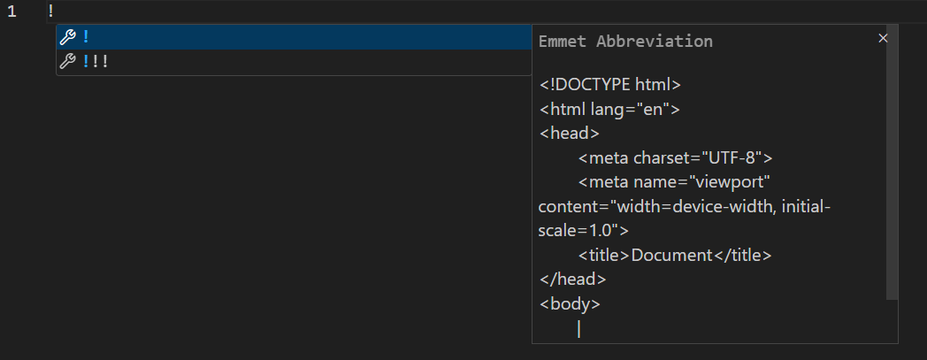

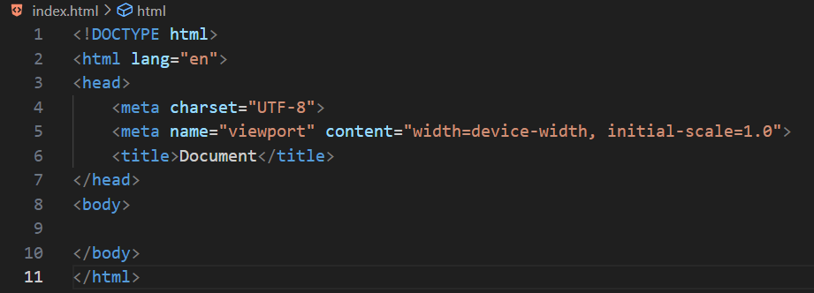



**Prettier - Code Formatter**

It fits in a single line so it’s going to stay as is. However, we've all run into this situation. For example, take the following code:

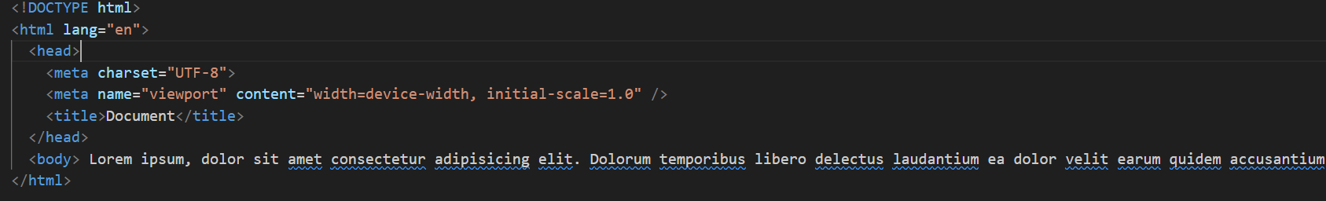

Prettier is going to do the painstaking work of reprinting it like this with proper indentation and formatting to make the code easier to read:

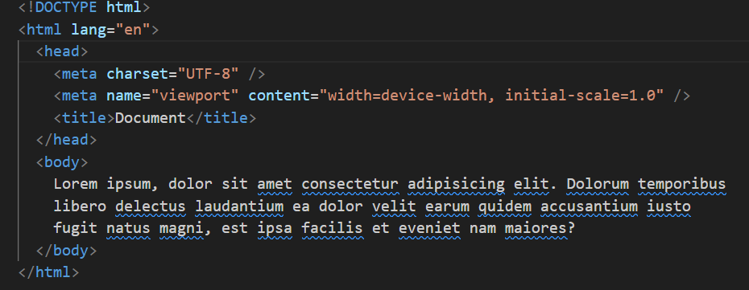





**Live Server**

The Live Server extension is a popular tool for web development in Visual Studio Code. It allows you to easily create a local development server, making it convenient to preview and test your web pages.



The changes made in the code are dynamically reflected:

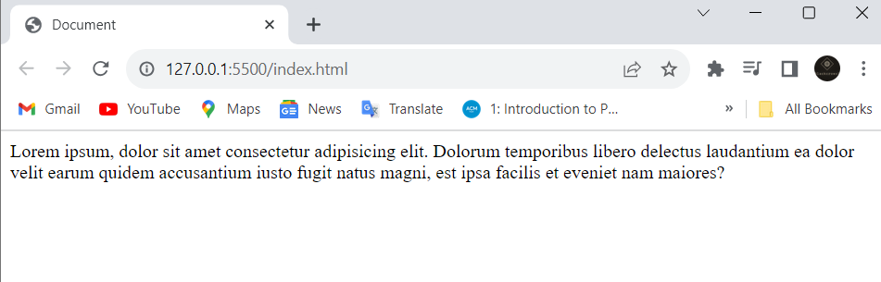





**Live Share**

Live Share enables you to quickly collaborate with a friend, classmate, or professor on the same code without the need to sync code or to configure the same development tools, settings, or environment.

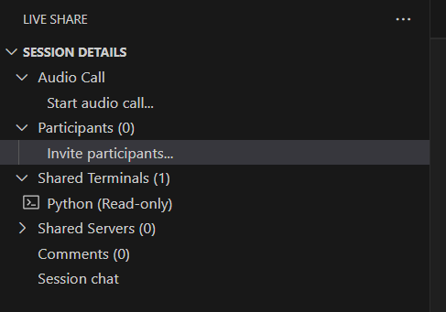





**Version Control with Git**

**Understanding Version Control**

* Definition and importance
* Benefits of version control in software development

**Setting Up Git in VS Code**

* Configuring global and project-specific settings
* Initializing a Git repository
* Ignoring files with .gitignore

**Basic Git Commands**

* Cloning repositories
* Making and committing changes
* Branching and merging

**Visualizing Changes**

* Using the Source Control view in VS Code
* Viewing and comparing changes
* Resolving merge conflicts



**Collaborating on GitHub**

* Integrating VS Code with GitHub
* Pushing and pulling changes
* Collaborative workflows and pull requests



**Blackbox AI in VS Code**

**Introduction to Blackbox AI**

* Defining blackbox AI
* Applications in software development
* Balancing automation and human input

**Integrating Blackbox AI Tools**

* Configuring blackbox AI extensions in VS Code
* Real-time code suggestions and improvements
* Ensuring privacy and security

**Using Blackbox AI in Code Reviews**

* Leveraging AI for code quality assessments
* Enhancing collaboration and learning
* Addressing common challenges and concerns





**GitHub Copilot**

**Overview of GitHub Copilot**

* Introduction to Copilot and its origins
* Understanding the capabilities of Copilot
* How Copilot interprets natural language

**Setting Up GitHub Copilot in VS Code**

* Installing the Copilot extension
* Configuring settings and preferences
* Exploring key features and functionalities

**Coding with GitHub Copilot**

* Writing code with Copilot's assistance
* Customizing generated code snippets
* Best practices and tips for effective use

**Prerequisites**

* Basic knowledge of programming and software development concepts.
* A laptop with Visual Studio Code installed.
* An active GitHub account for hands-on exercises.



**Resources**

* [Visual Studio Code Documentation] <https://code.visualstudio.com/docs>
* [Git Documentation] <https://git-scm.com/doc>
* [GitHub Copilot Documentation] <https://github.com/github/copilot>
* [Github Student Developer pack] <https://education.github.com/pack>

**Conclusion**

By the end of this workshop, you will have a deep understanding of Visual Studio Code, version control with Git, leveraging blackbox AI, and using GitHub Copilot to enhance your coding experience. Feel free to ask questions and engage in hands-on activities to solidify your learning. Happy coding!

**Installing Blackbox AI Extension**

**Step 1: Open Visual Studio Code**

Ensure that you have Visual Studio Code installed on your system. If not, you can download it from [Visual Studio Code's official website](https://code.visualstudio.com/).

**Step 2: Open Extensions View**

Press `Ctrl + Shift + X` (Windows/Linux) or `Cmd + Shift + X` (Mac) to open the Extensions view.

**Step 3: Search for Blackbox AI Extension**

In the Extensions view, search for "Blackbox AI" in the search bar.

**Step 4: Install the Extension**

Locate the "Blackbox AI" extension in the search results.

Click on the "Install" button next to the extension to install it.

**Step 5: Reload VS Code**

After installation, click the "Reload" button to reload Visual Studio Code and activate the Blackbox AI extension.

**Step 6: Configure Blackbox AI (if needed)**

Some AI extensions may require additional configuration. Check the extension documentation or settings in the VS Code settings.json file if needed.



**Installing GitHub Copilot Extension**

**Step 1: Open Visual Studio Code**

Ensure that you have Visual Studio Code installed on your system.

**Step 2: Open Extensions View**

Press `Ctrl + Shift + X` (Windows/Linux) or `Cmd + Shift + X` (Mac) to open the Extensions view.

**Step 3: Search for GitHub Copilot Extension**

In the Extensions view, search for "GitHub Copilot" in the search bar.

**Step 4: Install the Extension**

Locate the "GitHub Copilot" extension in the search results.

Click on the "Install" button next to the extension to install it.

**Step 5: Reload VS Code**

After installation, click the "Reload" button to reload Visual Studio Code and activate the GitHub Copilot extension.





**Step 6: Sign in to GitHub (if needed)**

Some GitHub extensions, including GitHub Copilot, may require you to sign in to your GitHub account. Follow the prompts to sign in.

**Step 7: Configure GitHub Copilot (if needed)**

GitHub Copilot usually works out of the box, but you can check its settings for customization. Press `Ctrl + ,` (Windows/Linux) or `Cmd + ,` (Mac) to open the settings, and search for "GitHub Copilot" to find relevant configuration options.

Now, you should have both the Blackbox AI and GitHub Copilot extensions installed and ready to use in Visual Studio Code for the workshop. Feel free to explore and experiment with these powerful tools during the hands-on exercises.

